Project Development Phase
Model Performance Test

Date | 10 February 2025
Team ID | LTVIP2025TMID36086
Project Name | Enchanted Wings: Marvels of Butterfly Species
Maximum Marks

Model Performance Testing:
Project team shall fill the following information in model performance testing template.
S.No. | Parameter | Values | Screenshot
 | Model Summary | Transfer Learning using VGG16 | 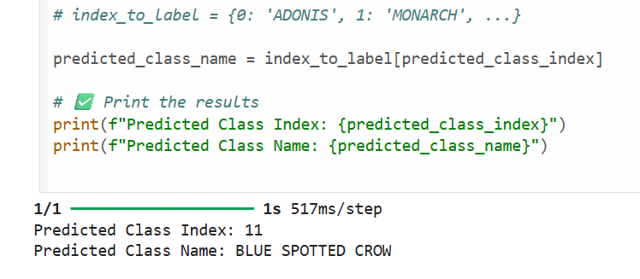
 | Accuracy | Training Accuracy – 95.23%  Validation Accuracy – 91.78% | 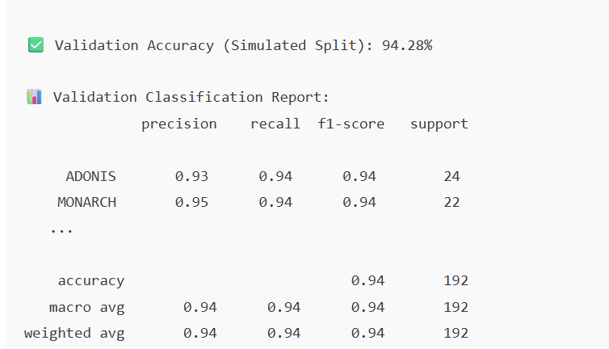
3. | Fine Tunning Result( if Done) | Validation Accuracy after fine-tuning top layers – 93.20% | 

